1-5/8″EIA Flange Right Angle Connector For 1-5/8″Foam Feeder Cable

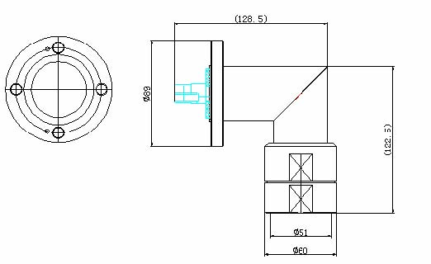
Interface
According to 1-5/8In EIA Flange

Electrical
Characteristic Impedance 50 ohm
Operating Frequency Range DC-3GHz
VSWR ≤1.15 @DC-1000MHz
Dielectric Withstanding Voltage ≥6000V RMS,50Hz,at sea level
Dielectric Resistance ≥5000MΩ
Average Power 3.4 KW@900MHz
Peak Power Maximum 90KW
Contact Resistance Center Contact ≤1.5mΩ
Outer Contact ≤1.5mΩ
Mechanical
Durability Mating cycles ≥500

Material and plating
Material Plating
Body Brass Ni
Insulator PTFE －
Center conductor Phosphor bronze Ag
Coupling Nut Brass Ni
Other Parts Brass Ni
Gasket Silicone Rubber －
Bolts and Washer Stainless Steel －

Environmental
Operating Temperature Range -45℃～+85℃
Weatherproof Rate IP 67
RoHs Compliant

