N DC-18GHz 2 Watts

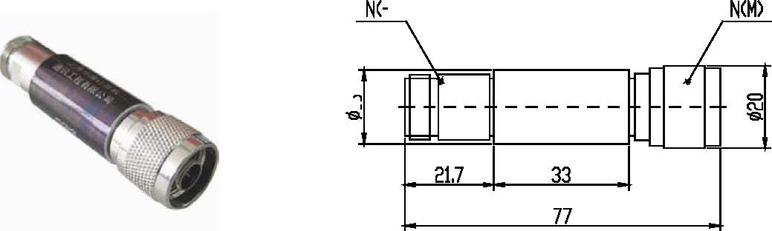

 | Frequency Range(GHz) | Attenuation Value & Accuracy (dB) |  |  |  |  |  | Max VSWR
 | Frequency Range(GHz) | 1-9 | 10 | 20 | 30 | 40
 | DC-4 | ±0.3 | ±0.3 | ±0.4 | ±0.4 |  | ±0.5 |  | 1.20
 | DC-6 | ±0.5 | ±0.4 | ±0.4 | ±0.5 |  | ±0.6 |  | 1.30
 | DC-8 | ±0.5 | ±0.4 | ±0.4 | ±0.5 |  | ±0.6 |  | 1.30
 | DC-12.4 | ±0.7 | ±0.7 | ±0.7 | ±0.7 |  | ±0.75 |  | 1.35
 | DC-18 | -0.4/+1.2 | ±1.0 | ±1.2 | ±1.2 |  | ±1.2 |  | 1.40

