2 Watt N Type Coaxial Attenuator
Drawing and Dimension:
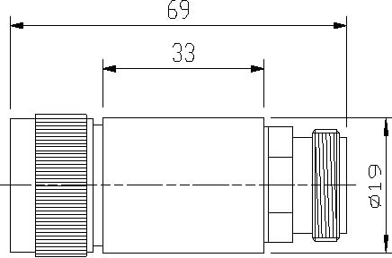
Operating Freq. |  | DC –3GHz
Average Power |  | 2 Watt
Peak Power |  | 5µs:0.5KW
Attenuation Value | 3dB | 5dB | 6dB | 10dB | 15dB | 20dB | 30dB
Accuracy | ±0.3 | ±0.5dB | ±0.5dB | ±0.7dB | ±0.7dB | ±0.8dB | ±0.8dB
VSWR |  | ≤1.15
Connector |  | N- Male / Female
Impedance |  | 50Ω
Operating Temp. |  | -30～+65℃
Weight |  | 75g

