10Watt N Type Coaxial Attenuator

Drawing and Dimension:
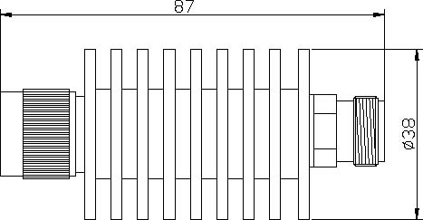
Operating Freq | DC –3GHz
Average Power | 10Watt
Peak Power | 5µs：1KW
Attenuation Value | 3dB | 5dB | 6dB | 10dB | 15dB | 20dB | 30dB
Accuracy | ±0.3dB | ±0.5dB | ±0.5dB | ±0.7dB | ±0.7dB | ±0.8dB | ±0.8dB
VSWR | ≤1.15
Connector | N-Male / Female
Impedance | 50Ω
Operating Temp. | -40～+85℃
Coating | Black plated
Weight | 120g

