50 Watt SMA type Coaxial Fixed Attenuator

Drawing and Dimension:

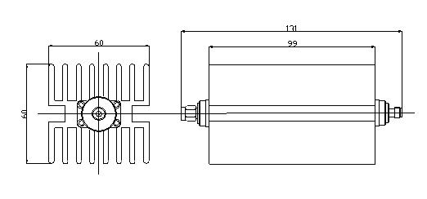

Operating Freq. | DC –3GHz
Average Power | 50W
Peak Power | 5µs：1KW
Attenuation Value | 3dB | 5dB | 6dB | 10dB | 15dB | 20dB | 30dB
Accuracy | ±0.3d | ±0.5dB | ±0.5dB | ±0.7dB | ±0.7dB | ±0.8dB | ±1dB
VSWR | ≤1.2
Connector | SMA- Male / SMA- Female
Impedance | 50Ω
Housing | Aluminum(Black Plating )
Connector body | Brass (Nickel Plating )
Inner conductor | Phosphor Bronze (Gold plating)
Gasket Parts | Silicone Rubber
Operating Temp. | -40～+80℃
Coated | Black plated
Weight | 430g

