10W SMA Type Coaxial Dummy Load (Terminator )

Drawing and Dimension:
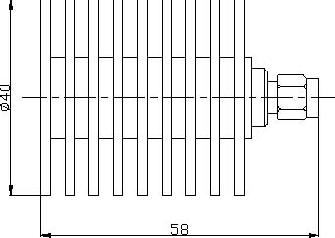
Freq. range | DC-3GHz
Power | 10W
VSWR | ≤1.10
Impedance | 50Ω
Connector | SMA-Male
Housing | Aluminum
Operating Temp. | -40～+85℃
Waterproof rate | IP67
Storage Temp. | -60～+100℃
Weight | 95g

