50W 7/16 DIN type Coaxial Dummy Load (Terminator)

Freq. Range | DC-3GHz
Power capacity | 50W
VSWR | ≤1.20
Impedance | 50Ω
Interface Port | 7/16 DIN- Male
Housing and Plating | Aluminum /Black Passivation
Connector Material | Brass (Ni &Silver Plating)
Operating Temp. | -40～+85℃
Waterproof rate | IP67
Storage Temp. | -40～+85℃
Weight | 950g

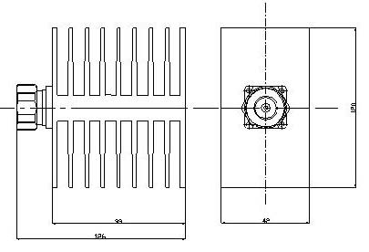
Drawing and Dimension:

