100W 7/16 DIN type Coaxial Dummy Load (Terminator)

Drawing and Dimension:
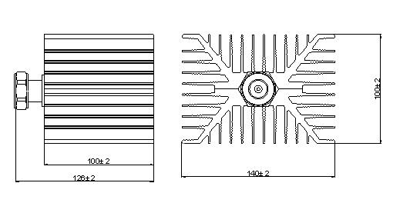
Freq. Range | DC-3GHz
Power capacity | 100W
VSWR | ≤1.20@DC-3GHz
Impedance | 50Ω
Interface Port | 7/16 DIN- Male
Housing and Plating | Aluminum /Black Passivation
Connector Material | Brass (Ni &Silver Plating)
Operating Temp. | -45～+85℃
Waterproof rate | IP67
Storage Temp. | -60～+120℃
Weight | 1200g

