SMA Female Bulkhead Crimp Connector For RG58 Cable

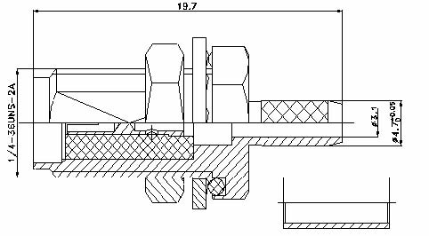

Interface
According to IEC 60169-15

Electrical
Characteristic Impedance 50 ohm
Typical Frequency Range DC-6GHz
VSWR ≤1.25@DC-3GHz
Dielectric Withstanding Voltage ≥1000V RMS,50Hz,at sea level
Dielectric Resistance ≥5000MΩ
Contact Resistance Center Contact ≤3mΩ
Outer Contact ≤2.5mΩ
Mechanical
Durability Mating Cycles ≥500

Material and Plating
Material Plating
Body Brass Au
Insulator PTFE(Teflon) －
Center conductor Phosphor Copper Au
Nut Brass Au
Ferrule Annealed Copper Ni
Washer Brass Au
Gasket Silicone Rubber －

Environmental
Operating Temperature Range -40℃～+85℃
RoHs Compliant

