BNC Male to BNC Female Right Angle Adaptor

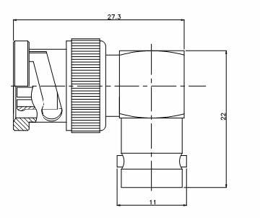

Interface
According to IEC 60169-8
Electrical
Characteristic Impedance 50 ohm
Frequency Range DC- 4GHz
VSWR ≤1.25@DC-3000MHz
Insertion Loss ≤0.10dB
Dielectric Withstanding Voltage ≥1500V RMS,50Hz,at sea level
Dielectric Resistance ≥5000MΩ
Contact Resistance Center Contact ≤1.5mΩ
Outer Contact ≤1.0 mΩ
Mechanical
Durability Mating cycles ≥500

Material and Plating
Material Plating
Body Brass Ni
Insulator PTFE －
Center conductor Phosphor bronze Au
Coupling Nut Brass Ni
Gasket Silicone Rubber －

Environmental
Temperature Range -40℃～+85℃
Weatherproof Rate IP 67
RoHs Compliant

