BNC Double Male to BNC Female H Shape Adaptor

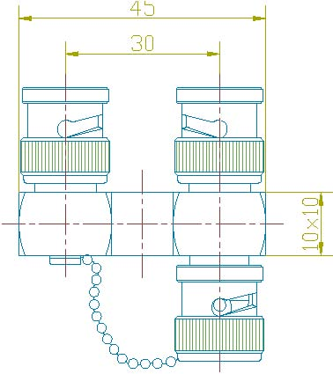

Interface
According to IEC 60169-8

Electrical
Characteristic Impedance 75 ohm
Frequency Range DC-4GHz
VSWR ≤1.30@DC-1000MHz
Dielectric Withstanding Voltage ≥1500V RMS,50Hz,at sea level
Dielectric Resistance ≥5000MΩ
Contact Resistance Center Contact ≤1.5mΩ
Outer Contact ≤1.0 mΩ

Mechanical
Durability Mating cycles ≥500
Material and plating
Material Plating
Body Brass Ni
Insulator PTFE －
Center conductor Phosphor bronze Au
Coupling Nut Brass Ni
Other Parts Brass Ni
Gasket Silicone Rubber －

Environmental
Temperature Range -40℃～+85℃
RoHs Compliant

