BNC Female Right Angle Connector For P.C.B Mount(PBT Housing)

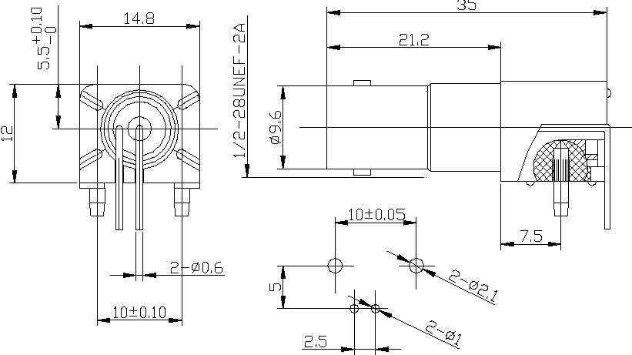

Interface
According to IEC 60169-8

Electrical
Characteristic Impedance 50 ohm
Frequency Range DC-4GHz
VSWR ≤1.30@DC-1000MHz
Dielectric Withstanding Voltage ≥1500V RMS,50Hz,at sea level
Dielectric Resistance ≥5000MΩ
Contact Resistance Center Contact ≤1.5mΩ
Outer Contact ≤1.0 mΩ

Mechanical
Durability Mating cycles ≥500
Material and plating
Material Plating
Body Zinc Alloy Ni
Housing PBT( white plastic) －
Insulator PE －
Center conductor Phosphor bronze Au
Solder Tail Copper wire Ag

Environmental
Temperature Range -40℃～+155℃
RoHs Compliant

