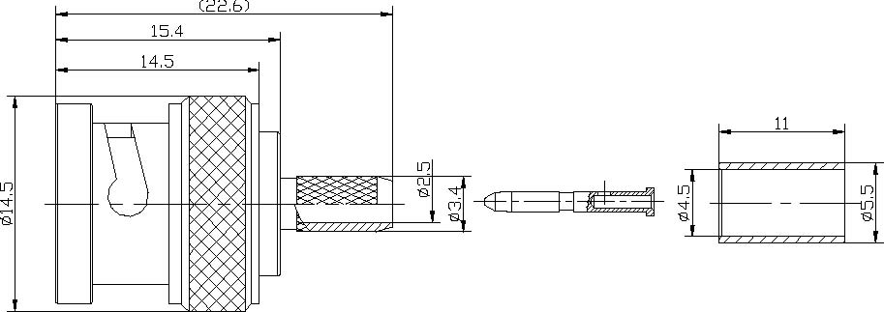
BNC Male Crimp Connector For Flex-3 Cable
Interface
According to |  | IEC 60169-8
Electrical
Characteristic Impedance |  | 75 ohm
Frequency Range |  | DC-4GHz
VSWR |  | ≤1.30@DC-1000MHz
Dielectric Withstanding Voltage |  | ≥1500V RMS,50Hz,at sea level
Dielectric Resistance |  | ≥5000MΩ
Contact Resistance |  | Center Contact ≤1.5mΩ
 |  | Outer Contact ≤1.0 mΩ
Mechanical
Durability |  | Mating cycles ≥500
Material and plating
 | Material | Plating
Body | Brass | Ni
Insulator | PTFE | －
Center conductor | Brass | Au
Coupling bayonet | Brass | Ni
Crimp Ferule | Annealed Copper | Ni
Gasket | Silicone Rubber | －
Environmental
Temperature Range |  | -40℃～+85℃
RoHs Compliant

Tel:0086-511-88896930;Fax:0086-511-88892399;Email:herryma71@hotmail.com;www.fscommunication.com

