BNC Male Crimp Connector For LMR400 Cable

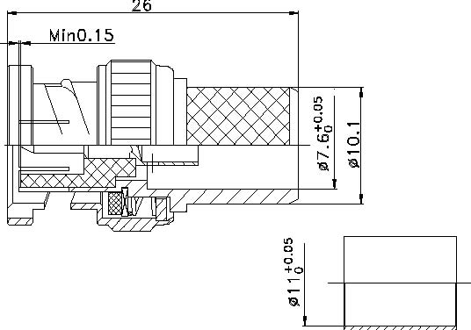

Interface
According to
Electrical
Characteristic ImpedanceFrequency RangeVSWR Dielectric Withstanding Voltage Dielectric Resistance Contact Resistance
Mechanical
Durability
Material and plating Body InsulatorCenter conductor Coupling NutCrimp FeruleGasket
Environmental
Temperature RangeRoHs Compliant MaterialBrass PTFE
Phosphor bronze Brass Annealed CopperSilicone Rubber
IEC 60169-8 50 ohm DC-4GHz ≤1.20@DC-3000MHz
≥1500V RMS,50Hz,at sea level ≥5000MΩ Center Contact ≤1.5mΩ
Outer Contact ≤1.0 mΩ
Mating cycles ≥500
Plating Ni
－
Au Ni Ni
－
-40℃～+85℃

