1.0/2.3 Male Crimp Connector For RG179 Cable

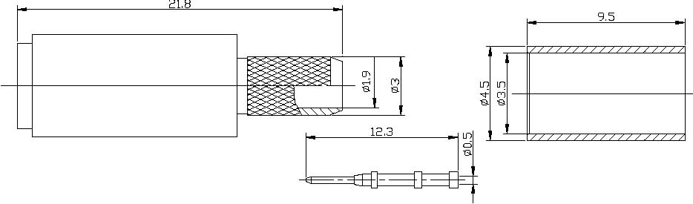
Interface
According to IEC 61169-29;CECC 22230;DIN47297

Electrical
Characteristic Impedance 75 ohm
Frequency Range DC-4GHz
VSWR ≤1.25@DC-1GHz
Dielectric Withstanding Voltage ≥750 V R.M.S,At sea level
Dielectric Resistance ≥1000MΩ
Contact Resistance Center Contact ≤4mΩ
Outer Contact ≤2.5mΩ

Mechanical
Durability Mating cycles ≥500

Material and plating
Material Plating
Body Brass Ni
Insulator PTFE －
Center conductor Phosphor bronze Au
Resilient Contact Phosphor bronze Au
Ferrule Annealed Copper Ni

Environmental
Temperature Range -40℃～+85℃
RoHs Compliant

