FME Male Crimp Connector For RG174 Cable
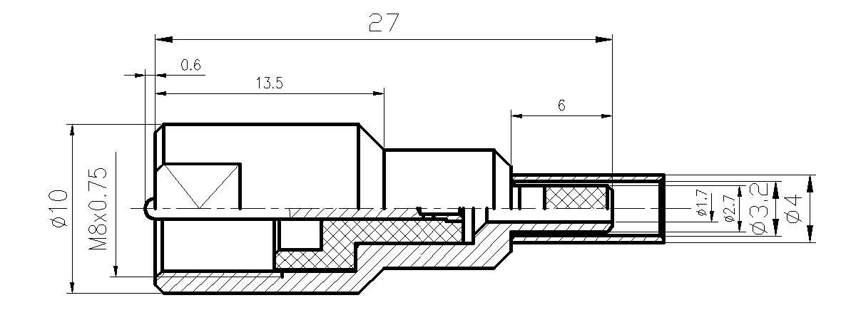
Electrical
Characteristic Impedance |  |  | 50 ohm
Typical Frequency Range |  |  | DC-3GHz
VSWR |  |  | ≤1.30@DC-1GHz
Dielectric Withstanding Voltage |  |  | ≥1000V RMS,50Hz,at sea level
Working Voltage |  |  | 500V RMS,50Hz,at sea level
Dielectric Resistance |  |  | ≥5000MΩ
Contact Resistance |  |  | Center Contact ≤10mΩ
 |  |  | Outer Contact ≤5mΩ
Mechanical
Durability |  |  | Mating Cycles ≥500
Material and Plating
 |  | Material | Plating
Body |  | Brass | Ni
Insulator |  | PTFE(Teflon) | －
Center conductor |  | Phosphor Copper | Au
Ferrule |  | Annealed Copper | Ni
Environmental
Operating Temperature Range |  |  | -40℃～+85℃
RoHs | Compliant

