1.6/5.6 Female Bulkhead Right Angle Clamp Connector For Flex-3Cable

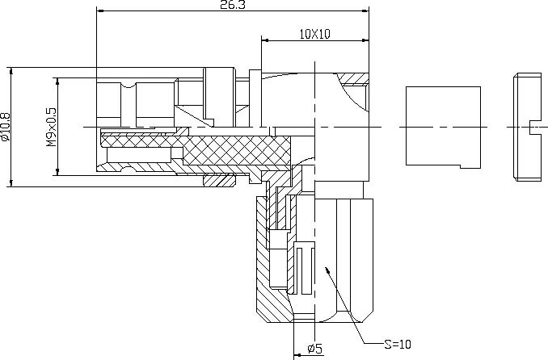

Interface
According to IEC 60169-13;CECC 22240;DIN47259

Electrical
Characteristic Impedance 75 ohm
Frequency Range DC-1GHz
VSWR ≤1.05@DC-100MHz
≤1.25@100-1000MHz
Dielectric Withstanding Voltage ≥1000 V R.M.S,At sea level
Dielectric Resistance ≥10000MΩ
Peak Working Voltage 330V
Contact Resistance Center Contact ≤4mΩ
Outer Contact ≤2mΩ
Mechanical
Withdrawal force inner female contact 0.5N Minimum
Withdrawal force inner male contact 1.7N Minimum
Insertion force between female and male 12 N Maximum
Withdrawal force between female and male 22N Minimum
Durability Mating cycles ≥500
Material and plating
Material Plating
Body Brass Au/Ni
Insulator PTFE －
Center conductor Phosphor bronze Au
Resilient Contact Phosphor bronze Au
Coupling Nut Brass Ni
Other Parts Brass Ag

Environmental
Temperature Range -40℃～+85℃
RoHs Compliant

