1.6/5.6 Male Straight Clamp Connector For RG59 Cable

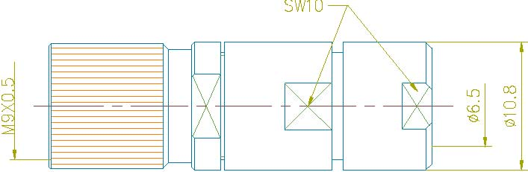

Interface
According to IEC 61169-13;CECC 22240;DIN47259

Electrical
Characteristic Impedance 75 ohm
Frequency Range DC-1GHz
VSWR ≤1.25@DC-1GHz
Dielectric Withstanding Voltage ≥1000 V R.M.S,At sea level
Dielectric Resistance ≥10000MΩ
Contact Resistance Center Contact ≤4mΩ
Outer Contact ≤2mΩ

Mechanical
Durability Mating cycles ≥500

Material and plating
Material Plating
Body Brass Ni
Insulator PTFE －
Center conductor Phosphor bronze Au
Resilient Contact Phosphor bronze Au
Coupling Nut Brass Ni
Other Parts Brass Ag
Gasket(O-ring) Silicone Rubber －

Environmental
Temperature Range -40℃～+85℃
RoHs Compliant

