MCX Male Straight Connector For P.C.B Mount

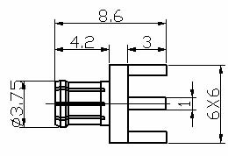

Interface
According to IEC 61169-36;CECC 22220

Electrical
Characteristic Impedance 50 ohm
Frequency Range DC-6GHz
VSWR ≤1.10@DC-3GHz
Dielectric Withstanding Voltage ≥750V RMS,50Hz,at sea level
Dielectric Resistance ≥1000MΩ
Contact Resistance Center Contact ≤5mΩ
Outer Contact ≤2.5mΩ

Mechanical
Durability Mating cycles ≥500

Material and plating
Material Plating
Body Brass Au
Insulator PTFE －
Center conductor Phosphor bronze Au
Resilient Contact Phosphor bronze Au
Gasket(O-ring) Silicone Rubber －

Environmental
Temperature Range -40℃～+85℃
RoHs Compliant

