MMCX Male Right Angle Crimp Connector For RG178 Cable

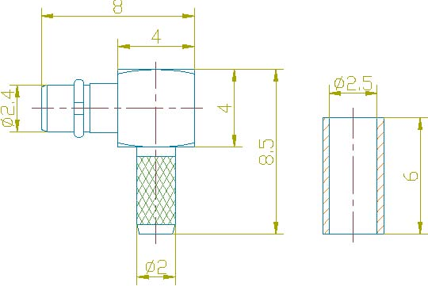

Interface
According to CECC 22340

Electrical
Characteristic Impedance 50 ohm
Frequency Range DC-6GHz
VSWR ≤1.25@DC-3GHz
Dielectric Withstanding Voltage ≥500V RMS,50Hz,at sea level
Dielectric Resistance ≥1000MΩ
Contact Resistance Center Contact ≤5mΩ
Outer Contact ≤2.5mΩ

Mechanical
Durability Mating cycles ≥500

Material and plating
Material Plating
Body Brass Au
Insulator PTFE －
Center conductor Phosphor bronze Au
Resilient Contact Phosphor bronze Au
Ferrule Annealed Copper Ni or Au

Environmental
Temperature Range -40℃～+85℃
RoHs Compliant

