SMB Female (Jack) Solder Pin Crimp Connector For RG316 Cable

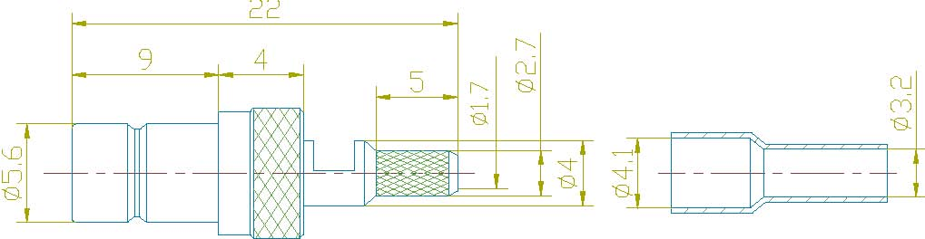

Interface
According to IEC 60169-10;CECC 22130;MIL-C-39012

Electrical
Characteristic Impedance 50 ohm
Typical Frequency Range DC-4GHz
VSWR ≤1.25@DC-3GHz
Dielectric Withstanding Voltage ≥1000V RMS,50Hz,at sea level
Dielectric Resistance ≥1000MΩ
Contact Resistance Center Contact ≤6mΩ
Outer Contact ≤1mΩ
Mechanical
Durability Mating Cycles ≥500

Material and Plating
Material Plating
Body Brass Au
Insulator PTFE(Teflon) －
Center conductor Phosphor Copper Au
Resilient Contact Phosphor bronze Au
Ferrule Annealed Copper Au

Environmental
Operating Temperature Range -40℃～+85℃
RoHs Compliant

