SMB Female (Plug) Crimp Connector For RG316 Cable
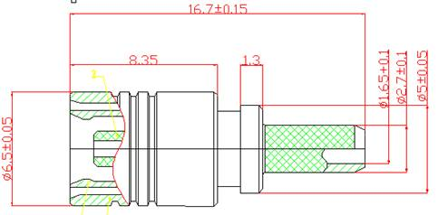
Interface
According to IEC 60169-10;CECC 22130;MIL-C-39012
Electrical
Characteristic Impedance 50 ohm
Typical Frequency Range DC-4GHz
VSWR ≤1.20@DC-3GHz
Dielectric Withstanding Voltage ≥1000V RMS,50Hz,at sea level
Dielectric Resistance ≥1000MΩ
Contact Resistance Center Contact ≤6mΩ
Outer Contact ≤1mΩ
Mechanical
Durability Mating Cycles ≥500
Material and Plating
Material Plating
Body Brass Au
Insulator PTFE(Teflon) －
Center conductor Phosphor Copper Au
Resilient Contact Phosphor bronze Au
Ferrule Annealed Copper Ni (or Au)
Environmental
Operating Temperature Range -40℃～+85℃
RoHs Compliant

