SMB Female Connector For BT3002 cable( CP and Body Crimp)

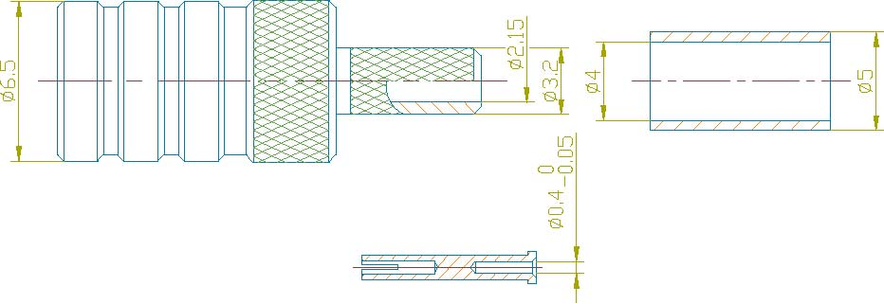

Interface  According to |  |  | IEC 60169-10
Electrical  Characteristic Impedance  Frequency Range  VSWR  Dielectric Withstanding Voltage  Dielectric Resistance  Contact Resistance |  |  | 50ohm  DC-3GHz  ≤1.3@DC-3GHz  ≥750V RMS,50Hz,at sea level  ≥1000MΩ  Center Contact ≤6mΩ  Outer Contact ≤1mΩ
Mechanical  Durability |  |  |  | Mating cycles≥500
Material and plating  Body  Insulator  Female Contact  Crimp Ferrule | Material  Brass  PTFE  Beryllium Copper  Copper Alloy | Plating  Au  -  Au  Au
Environmental  Temperature Range |  |  |  |  | －40℃～＋100℃
Drafted by: Approved by:

