SMB Jack (Female) Straight Connector For PCB Mount
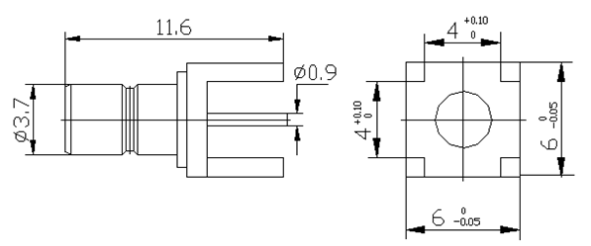
Interface  According to | IEC 60169-10 CECC 22130
Electrical  Characteristic Impedance  Frequency Range  VSWR  Dielectric Withstanding Voltage  Dielectric Resistance  Contact Resistance | 50ohm  DC-4GHz  ≤1.2@DC-3GHz  ≥1000V RMS,50Hz,at sea level  ≥1000MΩ  Center Contact≤6mΩ  Outer Contact≤1mΩ
Mechanical  Durability |  | Mating cycles≥500
Material and plating  Body  Insulator  Female Contact | Material  Brass  PTFE  Phosphor Copper |  |  | Plating  Au  -  Au
Environmental  Temperature Range |  |  | －40℃～＋125℃
Drafted by: Approved by:

