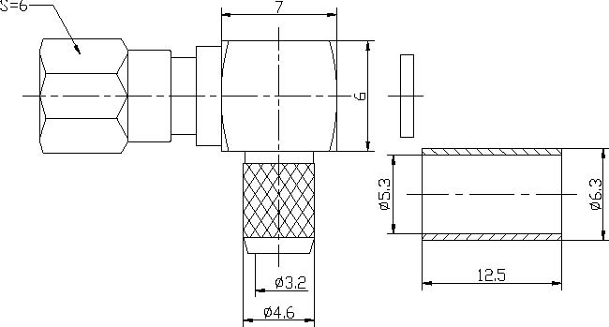
SMC Female Right Angle Crimp Connector For RG58 Cable
Interface
According to |  | IEC 60169-9；CECC22140；DIN47225
Electrical
Characteristic Impedance |  | 50 ohm
Typical Frequency Range |  | DC-6GHz
VSWR |  | ≤1.25@DC-3GHz
Dielectric Withstanding Voltage |  | ≥1000V RMS,50Hz,at sea level
Dielectric Resistance |  | ≥5000MΩ
Contact Resistance |  | Center Contact ≤6mΩ
 |  | Outer Contact ≤2.5mΩ
Mechanical
Durability |  | Mating Cycles ≥500
Material and Plating
 |  | Material | Plating
Body |  | Brass | Au
Insulator |  | PTFE(Teflon) | －
Center conductor |  | Phosphor Copper | Au
Resilient Contact |  | Phosphor bronze | Au
Ferrule |  | Annealed Copper | Ni
Gasket(O-ring) |  | Silicone Rubber | －
Environmental
Operating Temperature Range |  | -40℃～+85℃
RoHs | Compliant

