M4 Female Crimp Connector For BT3002 Cable

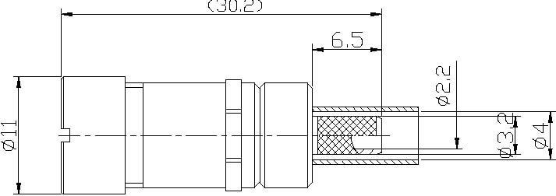

Interface
According to BS9210F0022
Electrical  Characteristic Impedance  Frequency Range  VSWR  Dielectric Withstanding Voltage  Dielectric Resistance | 75ohm  DC-3GHz  ≤1.30@DC-1GHz  ≥1000V RMS,50Hz,at sea level  ≥5000MΩ
Mechanical  Durability | Mating cycles≥500
Material and plating  Body  Insulator  Female Contact  Ferrule | Material  Copper  PTFE  Phosphor Bronze  Copper | Plating  Ag  -  Au  Ni
Environmental  Temperature Range | -40℃～ +120℃
Drafted by: Approved by:

