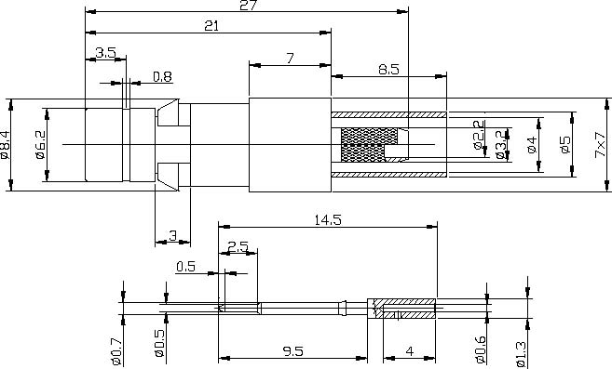
BT43(SMZ) Male Crimp Connector For BT3002 Cable
Interface
According to |  | BS9210F0022
Electrical
Characteristic Impedance |  | 75 ohm
Frequency Range |  | DC-3GHz
VSWR |  | ≤1.30@DC-1GHz
Dielectric Withstanding Voltage |  | ≥1500V RMS,50Hz,at sea level
Dielectric Resistance |  | ≥5000MΩ
Contact Resistance |  | Center Contact ≤5mΩ
 |  | Outer Contact ≤1mΩ
Mechanical
Durability |  | Mating cycles ≥250
Material and plating
 | Material | Plating
Body | Brass | Au
Insulator | PTFE | －
Center conductor | Phosphor bronze | Au
Ferrule | Annealed Copper | Ni
Environmental
Temperature Range |  | -40℃～+85℃
RoHs Compliant

