SMZ(BT43) Female(Solder Pin) Crimp Connector For BT3002 Cable

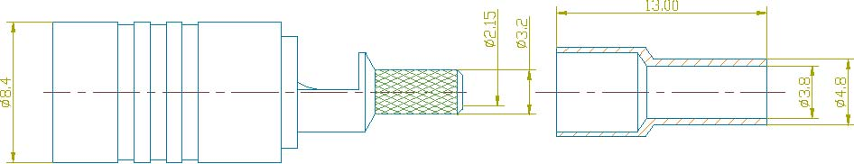

Interface

According to BS9210F0022

Electrical
Characteristic Impedance 75 ohm
Frequency Range DC-3GHz
VSWR ≤1.30@DC-1GHz
Dielectric Withstanding Voltage ≥1500V RMS,50Hz,at sea level
Dielectric Resistance ≥5000MΩ
Contact Resistance Center Contact ≤5mΩ
Outer Contact ≤1mΩ

Mechanical
Durability Mating cycles ≥250

Material and plating
Material Plating
Body Brass Ni
Insulator PTFE －
Center conductor Beryllium bronze Au
Spring Contact Phosphor bronze Au
Ferrule Annealed Copper Ni

Environmental
Temperature Range -40℃～+100℃
RoHs Compliant

