UHF Male Clamp Connector For RG213 Cable
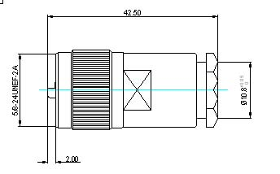

Interface
According to IEC 60169-12
Electrical Characteristic Impedance Non-Constant Frequency Range DC-300MHz VSWR ≤1.15 @DC-300MHz Dielectric Withstanding Voltage ≥2000V RMS,50Hz,at sea level Dielectric Resistance ≥5000MΩ Contact Resistance Center Contact ≤5.0mΩ
Outer Contact ≤5.0mΩ
Mechanical
Durability |  | Mating cycles ≥500
Material and plating
 | Material | Plating
Body | Brass | Ni
Insulator | PTFE | －
Center conductor | Phosphor bronze | Au
Coupling Nut | Brass | Ni
Other Parts | Brass | Ni
Gasket | Silicone Rubber | －
Environmental
Temperature Range |  | -40℃～+85℃
Weatherproof Rate |  | IP 68
RoHs Compliant

