UHF Male Crimp Connector For RG58 Cable

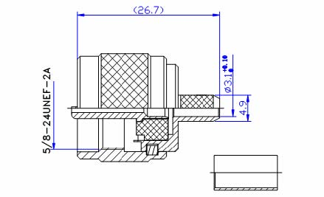

Interface
According to IEC 60169-12

Electrical
Characteristic Impedance Non-Constant
Frequency Range DC-300MHz
VSWR ≤1.20 @DC-300MHz
Dielectric Withstanding Voltage ≥2000V RMS,50Hz,at sea level
Dielectric Resistance ≥5000MΩ
Contact Resistance Center Contact ≤5.0mΩ
Outer Contact ≤5.0mΩ

Mechanical
Durability Mating cycles ≥500

Material and plating
Material Plating
Body Brass Ni
Insulator PTFE －
Center conductor Phosphor bronze Au
Coupling Nut Brass Ni
Crimp Tube Annealed Copper Ni
Gasket Silicone Rubber －

Environmental
Temperature Range -40℃～+85℃
Weatherproof Rate IP 68
RoHs Compliant

