TNC Male Clamp Connector For LMR400 Cable
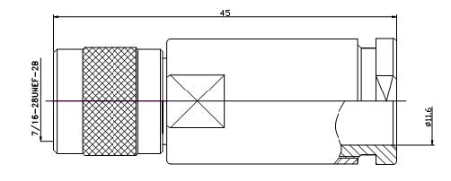
Interface
According to |  | IEC 60169-17;CECC 22200
Electrical
Characteristic Impedance |  | 50 ohm
Frequency Range |  | DC-11GHz
VSWR |  | ≤1.20@DC-3000MHz
Dielectric Withstanding Voltage |  | ≥1500V RMS,50Hz,at sea level
Dielectric Resistance |  | ≥5000MΩ
Contact Resistance |  | Center Contact ≤10mΩ
 |  | Outer Contact ≤2.5 mΩ
Mechanical
Durability |  | Mating cycles ≥500
Material and plating
 | Material | Plating
Body | Brass | Ni
Insulator | PTFE | －
Center conductor | Phosphor bronze | Au
Resilient Contact | Phosphor bronze | Ni
Coupling Nut | Brass | Ni
Other Parts | Brass | Ni
Gasket | Silicone Rubber | －
Environmental
Temperature Range |  | -40℃～+85℃
RoHs Compliant

