TNC Male Clamp Connector For RG213 Cable

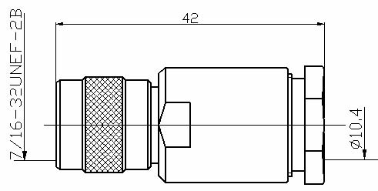

Interface
According to IEC 60169-17;CECC 22200

Electrical
Characteristic Impedance 50 ohm
Frequency Range DC-11GHz
VSWR ≤1.25@DC-3000MHz
Dielectric Withstanding Voltage ≥1500V RMS,50Hz,at sea level
Dielectric Resistance ≥5000MΩ
Contact Resistance Center Contact ≤10mΩ
Outer Contact ≤2.5 mΩ

Mechanical
Durability Mating cycles ≥500
Material and plating
Material Plating
Body Brass Ni
Coupling Nut Brass Ni
Insulator PTFE －
Center conductor Phosphor bronze Au
Resilient Contact Phosphor bronze Au
Sleeve (Clamp) Brass Ag
Coupling Nut Brass Ni
Gasket Silicone Rubber －

Environmental
Temperature Range -40℃～+85℃
RoHs Compliant

